REST - Country Web Service
Write a REST service that returns India country details in the earlier created spring learn application.
URL: /country
Controller: com.cognizant.spring-learn.controller.CountryController
Method Annotation: @RequestMapping
Method Name: getCountryIndia()
Method Implementation: Load India bean from spring xml configuration and return
Sample Request: http://localhost:8083/country
Sample Response:
{
"code": "IN",
"name": "India"
}
Implementation:
Country.java
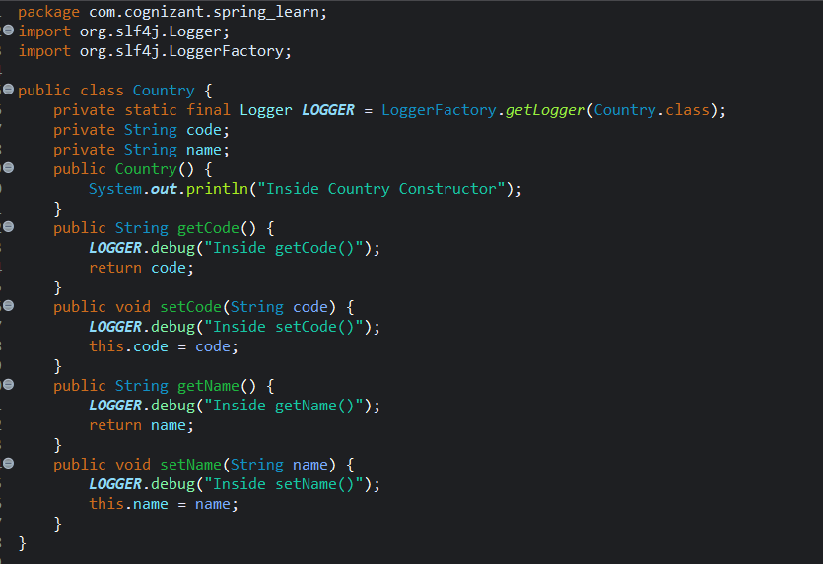
CountryController.java
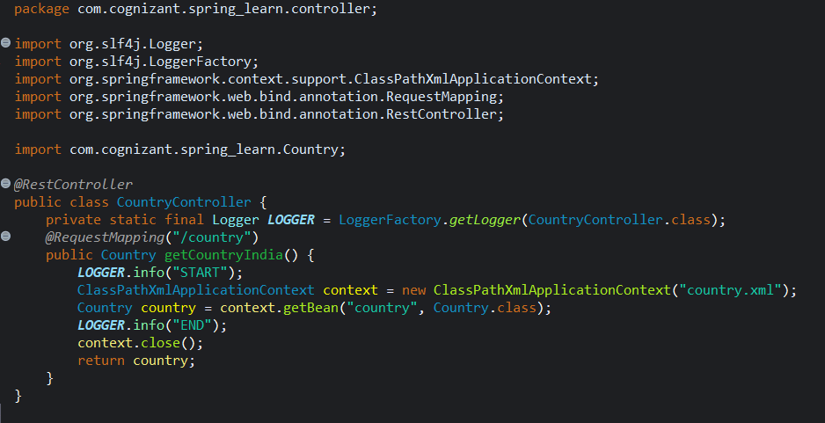

SpringLearnApplication.java
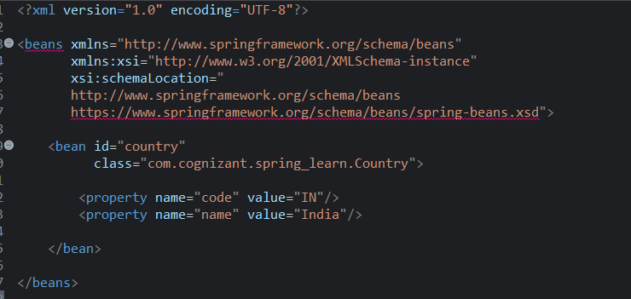

OUTPUT:
Console
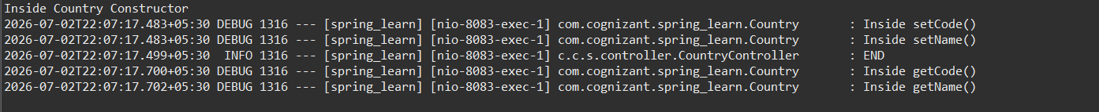

Browser
